Linux Architecture

Linux is an open-source UNIX-based operating system. The main component of the Linux operating system is Linux kernel.

Linux distribution is developed using a set of software based on compatibility with the Linux core kernel, using which Linux-based operations in different systems, such as personal systems, embedded systems, etc. There are around 600 distributions available.

**Some Linux distributions are:** MX Linux, Manjaro, Linux Mint, elementary, Ubuntu, Debian, Solus, Fedora, openSUSE, Deepin

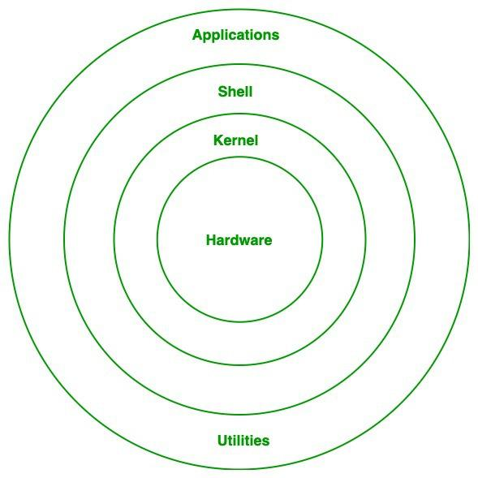

**Components of Linux:**

**The main components of Linux operating system are:** Application, Shell, Kernel, Hardware, Utilities.

1. Kernel: The kernel is the central component of Linux and regulates the operation of other hardware parts. It gives each process access to the virtual resources it needs and visualizes the shared hardware resources. In order to prevent conflicts of any type, it forces the process to wait in the ready queue and execute in turn.

Various kernel types:   
  
Single-Source Kernel:   
An operating system kernel that executes all concurrent processes simultaneously within it is known as a monolithic kernel. The same memory resources are used by all processes.   
  
Small kernel:   
User services and kernel services are run in different address regions in micro kernels. Kernel services are stored in kernel address space, while user services are stored in user address space.   
  
  
  
The exokernel   
Exo-kernel is made for application-level hardware resource management. This operating system uses high level abstraction to grant the kernel access to hardware resources.   
  
Kernel hybrid:   
It is a hybrid of a microkernel and a monolithic kernel. It has the versatility and stability of a microkernel along with the speed and design of a monolithic kernel.

2. System Libraries: Libraries that provide a consistent means of communication between the kernel and applications. They give programs access to system calls and function implementations so they can carry out tasks.  
As an illustration, one of the most important libraries is the GNU C Library (glibc), which offers fundamental features including memory allocation and input/output management.

3.Shell: An operating system-interactive command-line interface (CLI) that lets users communicate with it. It converts commands from the user into actions that the kernel can comprehend.  
Examples include Fish, Zsh, and Bourne Again Shell (Bash).  
Function: The shell allows users to run scripts, issue commands, and control system resources.

4.Hardware Layer: The lowest level of the Linux operating system is the hardware layer. It is essential to the management of every piece of hardware. Device drivers, kernel activities, memory control, CPU supervision, and I/O operations are all included. By guaranteeing the correct operation of each component and offering an interface for software, this layer generalizes hard complexity.

5.System utility:

System utilities are command line tools that execute a variety of tasks as specified by the user, enhancing system management and administration. These utilities allow users to carry out numerous functions, including file management, system monitoring, network configuration, and user management, among others.

-Tanishq Sharma

-0827CI221137